**WAP to Calculate number of vowels and characters in a string**

package program1;

import java.io.*;

import java.util.*;

class vovwels

{

public static void main(String args[]) throws IOException

{

String str;

int vowels = 0;

char ch;

int ch1,count=0;

BufferedReader br = new BufferedReader(new InputStreamReader(System.in));

System.out.print("Enter a String : ");

str = br.readLine();

System.out.println("Enter the choice 1 or 2 \n 1. To count vowels \n 2. To count characters");

Scanner sc=new Scanner(System.in);

ch1=sc.nextInt();

switch(ch1)

{

case 1 : for(int i = 0; i < str.length(); i++)

{

ch = str.charAt(i);

if(ch == 'a' || ch == 'A' || ch == 'e' || ch == 'E' || ch == 'i' ||

ch == 'I' || ch == 'o' || ch == 'O' || ch == 'u' || ch == 'U')

vowels++;

}

System.out.println("Vowels : " + vowels);

break;

case 2: for(int i = 0; i < str.length(); i++)

{

count++;

}

System.out.println("Characters : " + count);

break;

}

}

}

**OUTPUT**

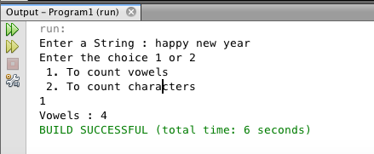

**WAP to print pattern**

package program1;

public class pattern1

{

public void show()

{

for(int i=1;i<=5;i++)

{

for(int j=i;j<5;j++)

{

System.out.print(" ");

}

for(int k=1;k<(i*2);k++)

{

System.out.print("*");

}

System.out.println();

}

}

public static void main(String[] args)

{

pattern1 p1=new pattern1();

p1.show();

}

}

**OUTPUT**

